Asian Parliamentary Assembly
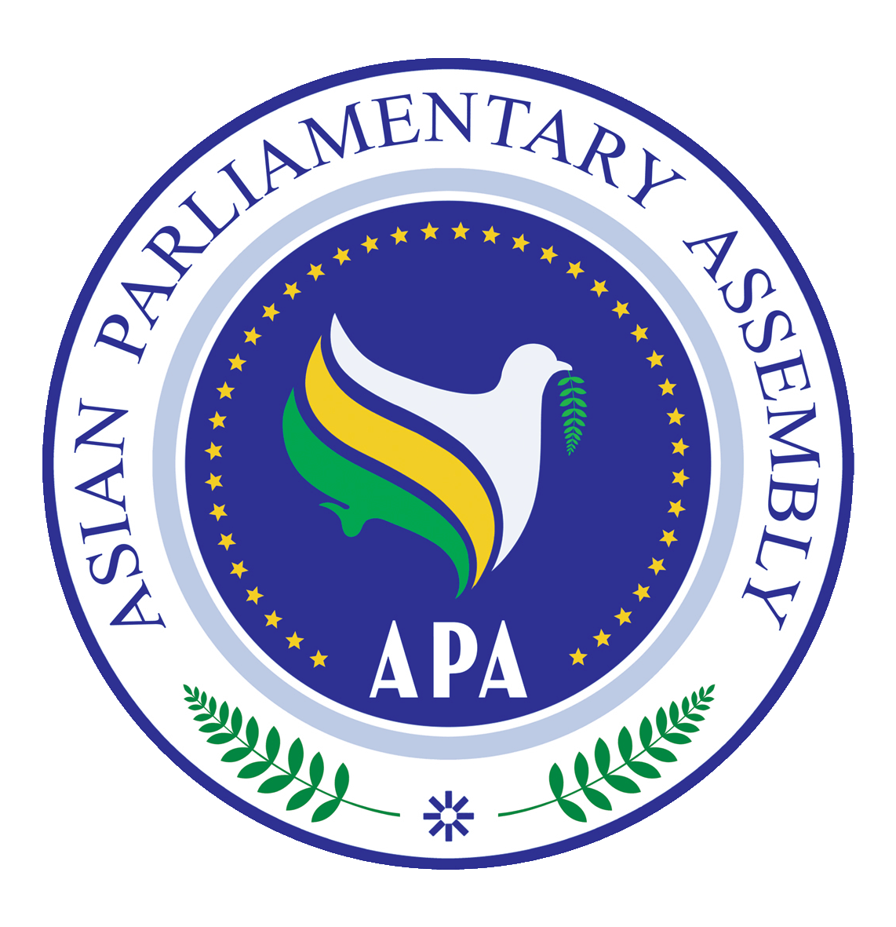 | Standing Committee on Social and Cultural Affairs  (Virtual Meeting)  Tehran- Islamic Republic of Iran  14 July 2021 | 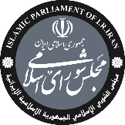
Registration Form
(6/7/2021 by APA Secretariat)
Delegation of: ………………………………
Name of Parliament

No. | First Name | Last Name | Position | Photo
Host Secretariat:  Email: conf@parliran.ir  Fax : +982133440306  Tel : +982133440307 | CC to APA Secretariat:  Email :secretariat@asianparliament.org  Fax : (+98-21) 33517408  Phone : (+98-21) 33517406-7

